**ETL Project Report**

**Project Proposal**

**Project Title –** Is the Uninsured Population a Driver in Creating Health Professional Shortages?

**Team Members –** Lissette Miranda, Rodrigo Anglarill, Ganesh Crooks

**Description of the scope of our research:**

The objective of our project is to determine whether there is a correlation between the reported Uninsured Population in Florida and the designated Health Professional Shortage Areas (HPSAs) in the same state. We are attempting to discover whether there is enough evidence to conclude that the uninsured population is another cause of what’s causing Health Professional shortages

**Hypothesis**: Our group’s hypothesis is that where there is a large number of uninsured people, there is also a bigger gap in Health professional services provided in that area in comparison to other areas.

**Finding Data**

**Datasets:**

Our datasets came from CSV files. Sources:

**Dataset 1** - Health Provider Shortage (HPSA in FL by County: <https://factfinder.census.gov/faces/nav/jsf/pages/guided_search.xhtml>

**Dataset 2** - Uninsured Population in FL by County: <https://data.hrsa.gov/tools/shortage-area/hpsa-find>

**ETL Process:**

1. **EXTRACT**

From the websites we used to retrieve data, we extracted the data in CSV files that we cleaned up as follows:

1. Using Jupyter Notebook, we .read both csv files:





1. **TRANSFORM**

From the data extracted, our cleaning process was as follows:  
Steps:

1. Removed columns on both datasets that were not relevant.
2. Renamed columns for clarity of content and manipulation.
   1. **Dataset 1** – HPSAs:

* We removed fields without a physical location (see note under image)
  1. **Dataset 2** – Uninsured:
* Edited county name fields to remove “Florida” from name for merging later on
* Removed row with FL totals from dataset and saved these “totals” outside of our dataset for analysis later on. Renamed columns





**Note:** We removed fields that lacked a physical location because we will focus on areas that have reported (designated) a shortage of physical, facility-type places that provide health services to the population. Fields that lacked a physical location were specific to doctors, healthcare providers (people).



1. **LOAD**

**Steps:**

1. We loaded the data into a relational database (MySQL)
   1. Created database named “medical_desert_db”
   2. Created 2 tables: “hpsa”, “uninsured”
2. In Jupyter Notebook, we connected to our local database
3. Loaded both dataframes into Jupyter (hpsa and uninsured)
4. Merged both tables on a common field (county)

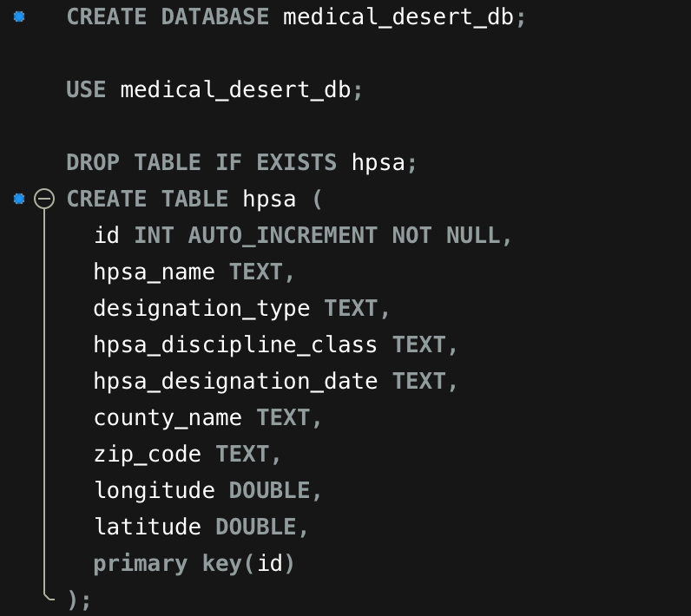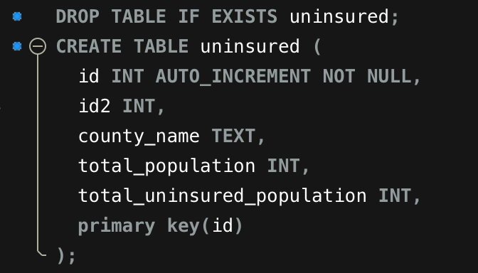

**LOAD into Jupyter:**



